**GIT**

**Madrid, Cordoba, Sevilla, Granada, Tangier, Fez, Marrakech, Casablanca- 9 nights**

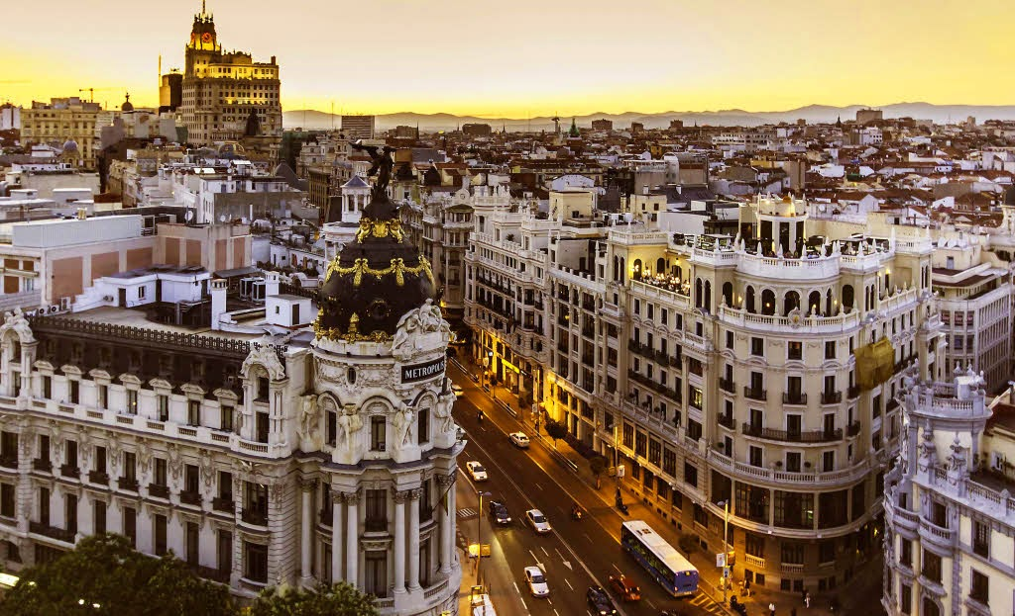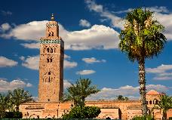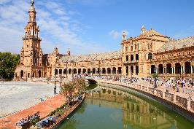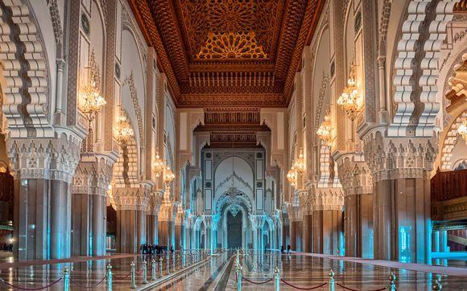

**day 1 Madrid**

English speaking assistance upon arrival at airport.

**private transfer** from Madrid airport to hotel.

half day **Madrid sightseeing** on private basis.

*this* ***half-day visit*** *offers a complete tour of the history and architecture of the city of Madrid:* ***Puerta de Alcalá, Cibeles, Puerta del Sol, Plaza de la Villa, Plaza Mayor****, Carrera de San Jerónimo, Calle Atocha, Reina Sofia Museum, Atocha main railway station, Ministry of Agriculture,* ***Prado Museum****, Banco de España, Paseo de* ***la Castellana, Bernabeu football stadium****.*

overnight at hotel in Madrid.

**day 2 Madrid**

breakfast at hotel.

half day **Toledo excursion** on private basis.

*Toledo is one of the Spanish cities with the greatest heritage of monuments. known as the “city of the three cultures”, Toledo preserves behind its walls an artistic and cultural legacy in the form of churches, palaces, fortresses, mosques and synagogues. some of the places you will see during the half-day tour are: the gothic cathedral, Santo Tomé church, Santa María la Blanca synagogue, the Alcázar, Casa Museo de el Greco, San Juan de Reyes Monastery and synagogue of “El Tránsito”.*

overnight at hotel in Madrid.

**day 3 Madrid – Córdoba**

breakfast at hotel and check out

**private transfer** from Madrid to hotel in Cordoba.

half day **Córdoba** **sightseeing** on private basis.

*departure to Córdoba via Antequera. upon arriving, panoramic tour of the* ***Roman Bridge,***

***the Jewish quarter, the synagogue*** *and* ***the mosque*** *(famous monument in the Islamic west, built on an ancient mosque and the materials of the Christian basilica of San Vicente). the tour includes inside visit of mosque.*

overnight at hotel in Cordoba.

**day 4 Córdoba – Sevilla**

breakfast at hotel and check out.

**private transfer** from Cordoba to the hotel in Sevilla.

half day **Sevilla sightseeing** on private basis.

*the tour starts at* ***the Isla de la Cartuja*** *which was chosen as the site for the expo’92. the* ***Plaza de España*** *and adjoining* ***Maria Luisa Park*** *are among the most pleasant and impressive public spaces in Spain. the tour continues in* ***Santa Cruz Quarters*** *with its narrow white alleys, flowered patios and wrought ironed balconies. the tour included inside visit of cathedral de Santa María de la Sede.*

overnight at hotel in Sevilla.

**day 5 Sevilla - Granada**

breakfast at hotel and check out.

half day **Alhambra sightseeing in Granada** on private basis.

***Granada*** *is situated at the foothills of the* ***Sierra Nevada Mountains****. it was once the capital of the Moorish Kingdom, a reign which lasted almost 800 years. this has left Granada with the most important Moorish legacy in Spain;* ***the Alhambra*** *(entrance fee included) the monument is one of the most brilliant jewels of universal architecture.*from Malaga to the hotel in Granada.

overnight at the hotel in Granada.

**day 6 Granada-Tangier**

breakfast at hotel and check out

**transfer on private basis** to Tarifa, in the region of Cádiz, to take the transfer Tangier.

after crossing the strait be transferred to your hotel in Tangier.

overnight at the hotel in Tangier.

**day 7 Tangier-Fes**

breakfast at hotel and check out

**short visit in private basis** in Tangier to walk through the medina; see the Kasbah and the Socco market. afterwards, transfer to the city of Fes.

**half day Fez sightseeing** on private basis.

*discover the Medersa Attarine, the largest and certainly one of the most beautiful,* ***the Place Nejjarine*** *with its magnificent fountain decorated with mosaics, wood and sculpted plaster.*

overnight at the hotel in Fes

**day 8 Fes-Marrakesh**

breakfast at hotel and check out

departure earlier to Marrakesh **the “pearl of the south**”, founded by the Almoravides dynasty at the end of the 12th century.

half day **Marrakesh sightseeing** on private basis.

visit the **Bahia Palace**, a palace and a set of gardens, and the Berber pharmacy then discovery of the souks of Marrakech and **the Djemaa El Fna**, which is a square and market place in Marrakech's medina quarter (old city).

overnight at the hotel in Marrakech

**day 9**

**Marrakesh-Casablanca**

breakfast at hotel and check out

departure to Casablanca.

visit of **“the white city”:** drive through the wide avenues and long stripes. Later walk through the narrow streets of the Medina. The tour also features visits to United Nations Square, Habous district. Hassan II Mosque and Corniche Boulevard. Inside visit of Hassan II Mosque.

afternoon at leisure for shopping.

overnight at the hotel in Casablanca

**day 10**

breakfast at hotel and check out

**private transfer** to Casablanca airport

**end of services**

**prices**

|  |  |  |  |  |  |  |
| --- | --- | --- | --- | --- | --- | --- |
| **package price per person** | **Nov - Mar** | | **Apr - Oct** | | **Jul - Aug** | |
| **standard class** | **pax** | **€** | **pax** | **€** | **pax** | **€** |
| **10** | 1643 | **10** | 1680 | **10** | 1636 |
| **15-19** | 1469 | **15-19** | 1507 | **15-19** | 1465 |
| **20-24** | 1377 | **20-24** | 1415 | **20-24** | 1375 |
| **25-29** | 1317 | **25-29** | 1355 | **25-29** | 1315 |
| **30-34** | 1305 | **30-34** | 1341 | **30-34** | 1305 |
| **35-39** | 1277 | **35-39** | 1302 | **35-39** | 1265 |
| **single suppl.** | **280 €** | | **290 €** | | **278 €** | |
| **first class** | **pax** | **€** | **pax** | **€** | **pax** | **€** |
| **10** | 1685 | **10** | 1749 | **10** | 1709 |
| **15-19** | 1511 | **15-19** | 1573 | **15-19** | 1537 |
| **20-24** | 1419 | **20-24** | 1481 | **20-24** | 1443 |
| **25-29** | 1359 | **25-29** | 1419 | **25-29** | 1383 |
| **30-34** | 1346 | **30-34** | 1375 | **30-34** | 1339 |
| **35-39** | 1307 | **35-39** | 1341 | **35-39** | 1306 |
| **single suppl.** | **295 €** | | **335 €** | | **311 €** | |
| **superior class** | **pax** | **€** | **pax** | **€** | **pax** | **€** |
| **10** | 2006 | **10** | 2105 | **10** | 1998 |
| **15-19** | 1827 | **15-19** | 1.922 | **15-19** | 1820 |
| **20-24** | 1733 | **20-24** | 1825 | **20-24** | 1726 |
| **25-29** | 1671 | **25-29** | 1763 | **25-29** | 1664 |
| **30-39** | 1596 | **30-39** | 1716 | **30-39** | 1620 |
| **40-45** | 1590 | **40-45** | 1677 | **40-45** | 1584 |
| **single suppl.** | **465 €** | | **534 €** | | **456 €** | |

*prices per person based on double room & hb basis. taxes included. valid for **minimum 15 pax, maximum 45 pax**. prices subject to availability and possible fluctuations in any of the requested services at the time of final booking

**validity**: **until October 2020.**

**inclusions:**

|  |  |  |  |  |
| --- | --- | --- | --- | --- |
| **city & nights** | **transfers** | **sightseeing on private basis** | **meals** | **24h phone assistance** |
| **2n Madrid** | **by coach** | half day city tour in Madrid  including entrance fee for royal palace  half day city tour in Toledo | breakfast  lunches  dinner |
| **1n Córdoba** | half day city tour including entrance fee for mosque |
| **1n Sevilla** | half day city tour including entrance fee for cathedral |
| **1n Granada** | half day city tour including entrance fee for Alhambra |
| **1n Tangier** | half day city tour |
| **1n Fes** | half day city tour |
| **1n Marrakech** | half day city tour |
| **1n Casablanca** | half day city tour |

* one person free of charge.

* ferry ticket from Tarifa to Tangier, included
* Porterage of luggage and tips at the hotels and restaurants in Morocco

**prices do not include:**

* regional tourist tax.
* tips and guests´ extras.
* any other service not mentioned on the programme / itinerary described.

**itinerary & number of nights**

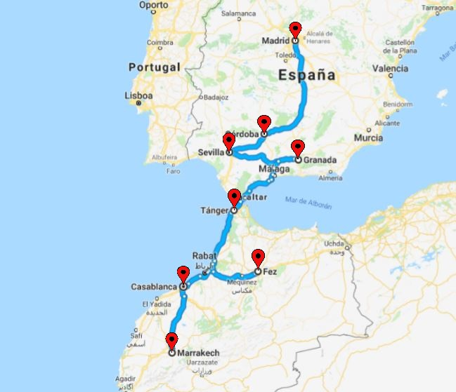

**1n Marrakesh**

**1n Casablanca**

**1n Fes**

**1n Tangier**

**1n Granada**

**1n Sevilla**

**1n Cordoba**

**2n Madrid**